Clement M. Narciso

IT231L

**System Protoyping**

The forms shown in the following figures are the forms of the Point of Sale (POS) System.

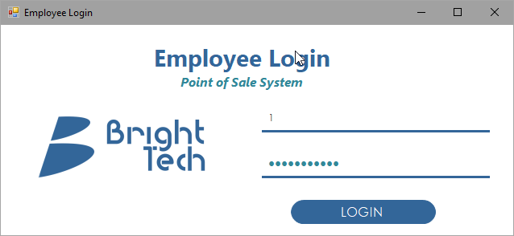

**Employee Login Form**

For employees to Login into the system

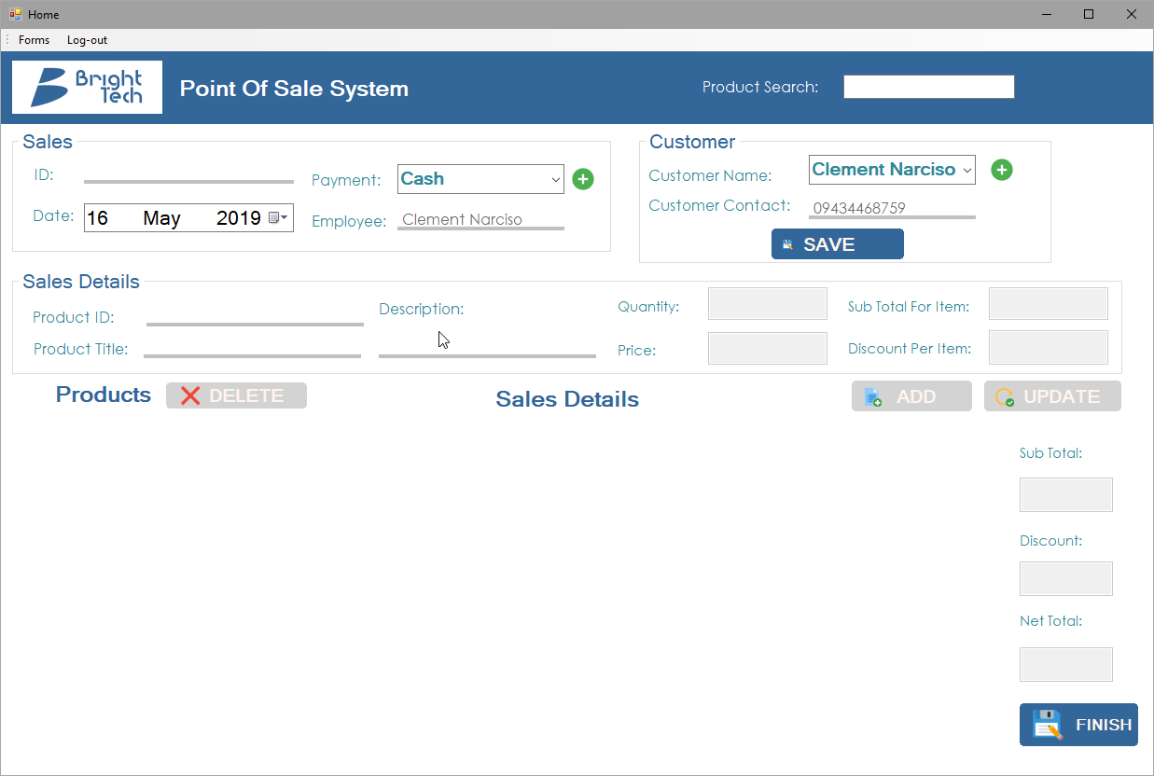

**Sales Form**

This is where the transactions happen in terms of selling products.

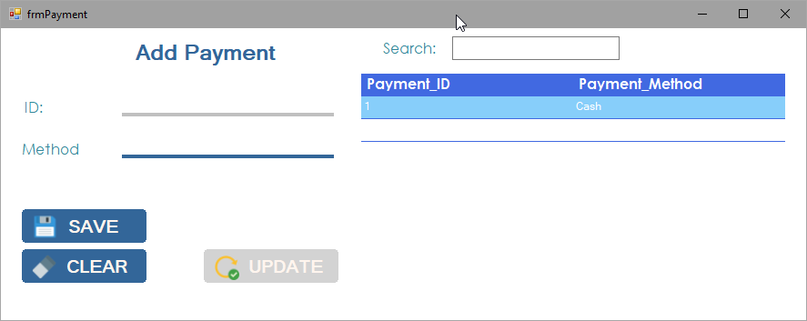

**Payment Form**

Adding payment method

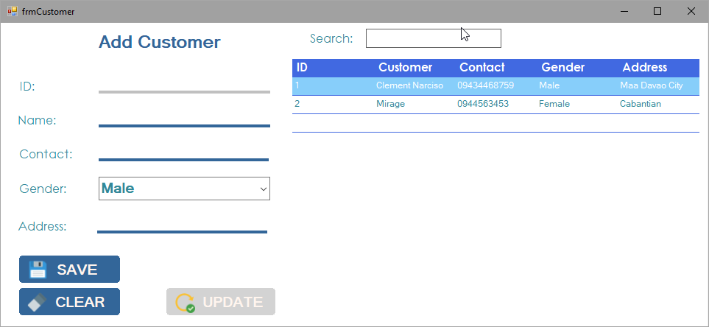

**Customer Form**

Adding customer and customer info

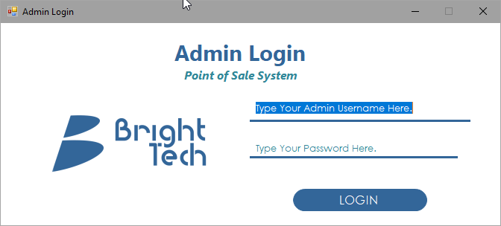

**Admin Login Form**

Login for admin to go to Admin Page.

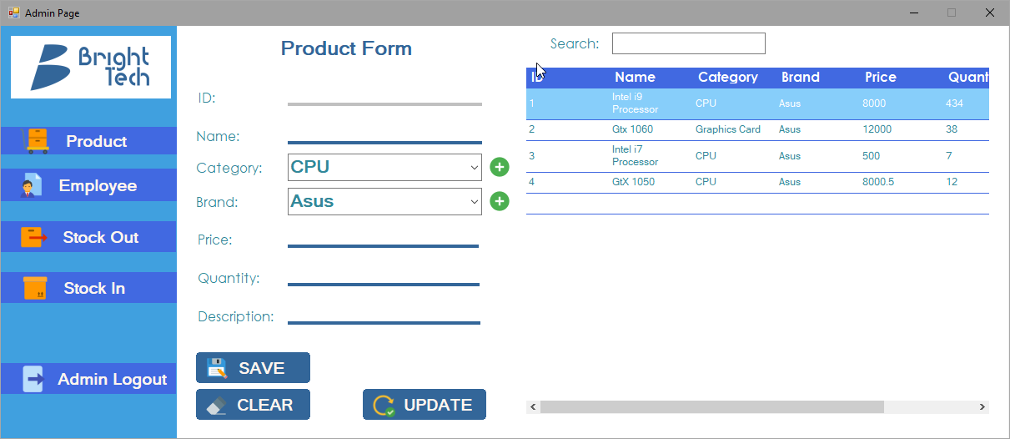

**Admin Page Form - Product Panel**

Adding new products for selling.

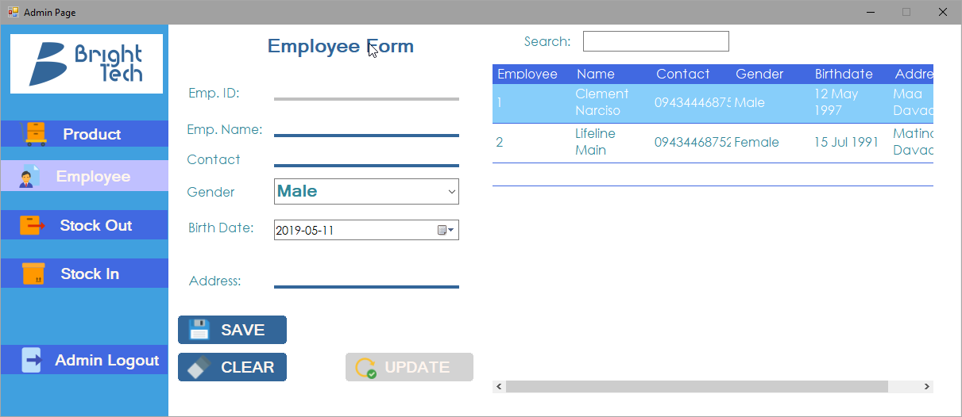

**Admin Page Form - Employee Panel**

Adding of new employees and their information.

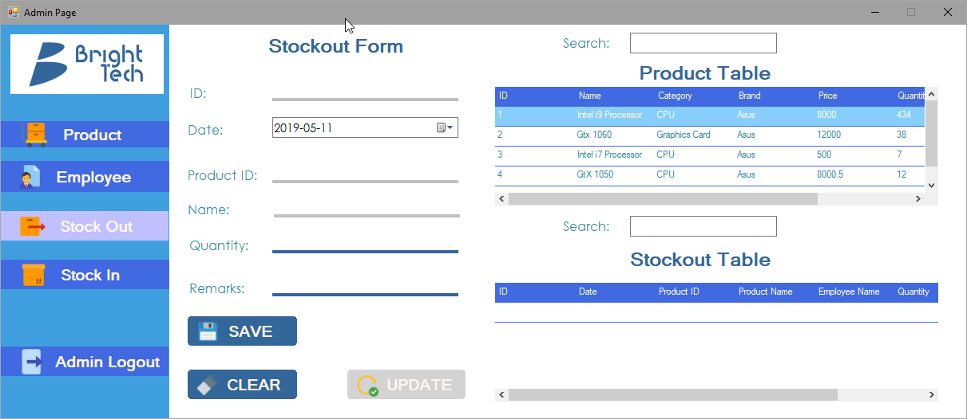

**Admin Page Form -Stockout Panel**

Removing of quantities in products because of reasons such as Lost, Broken and etc.

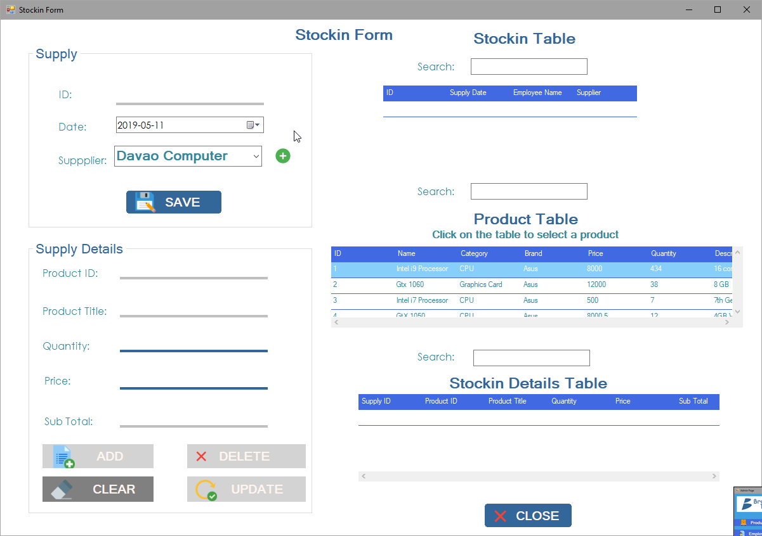

**Stock-in Form**

Adding or stocking up of quantities in products for reselling.

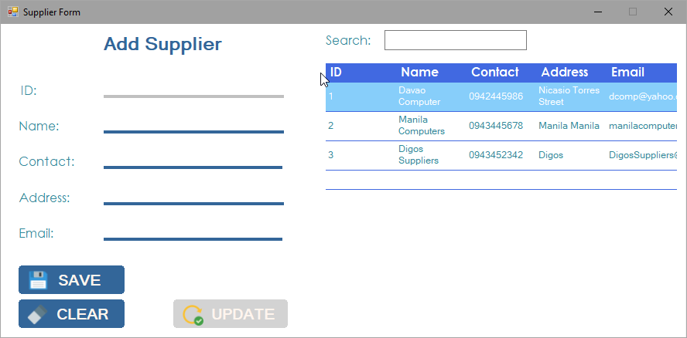

**Supplier Form**

Adding of supplier and their information.

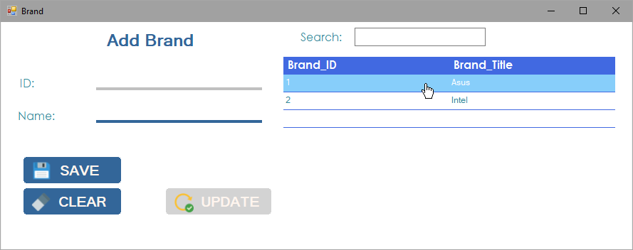

**Supplier Form**

Adding of supplier and their information

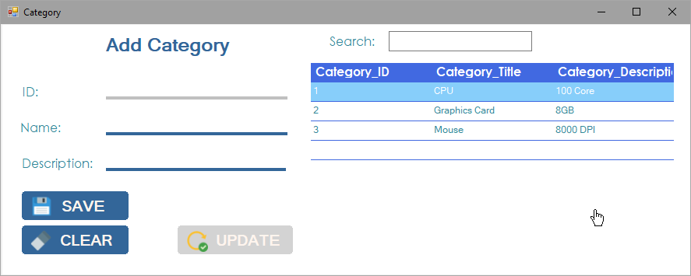

**Category Form**

Adding of category and its information

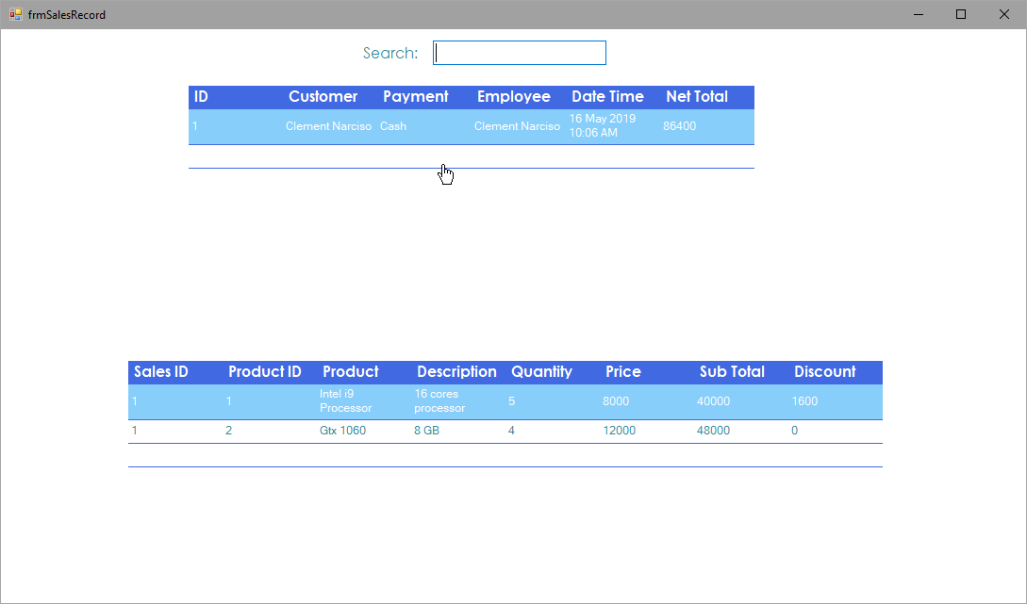

**Sales Record Form**

Viewing of sales information made from sales in sales form.